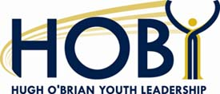It’s HOBY Time!

The Maryland Leadership Seminar May 23 – 26, 2013 at Mount St. Mary’s University, Emmitsburg, MD.

How you can help!

- Volunteer as a facilitator for a group of 9 to12 students at the seminar (spending nights in a dorm)
- Sponsor a Career Lunch table for $200 on Friday May 24, eat and converse with 7 students, then trade tables
- Donate food and snacks for 270
- Donate office supplies and printing
- Help on our service projects or as a day volunteer
- Help recruit sophomores from your neighborhood high schools
- Speak on a panel or lead a hands-on team building lab session
- Sponsor a student for $175
- We are a 501(c) (3) charitable foundation

If you want to see how the HOBY committee works, join us for our Sunday meetings – January 6, March 10 and May 5.

Carol Applegate JCI#49685
(H) 410-426-8287 (C) 410-746-0150
Past President Towson Jaycees capplegate@jhmi.edu
HOBY Corporate President 2008-2013

